# Deep Learning

Lab – 5

Name: Yadukrishnan

Reg. No: 21BAI1210

Link to all the codes given below: [Github](https://github.com/yadu-tv/deep-learning-lab/tree/main/lab_5)

1. Basics of PyTorch

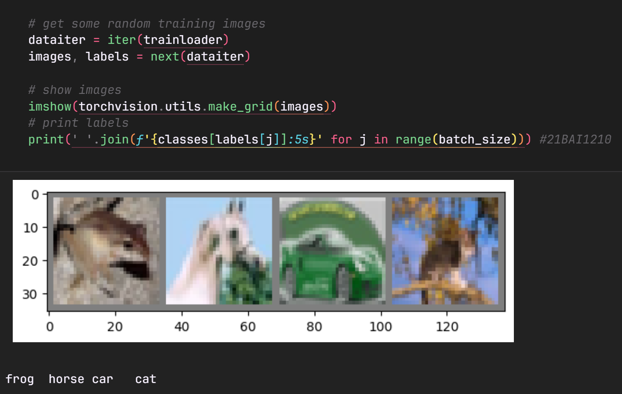

1. GoogleNet

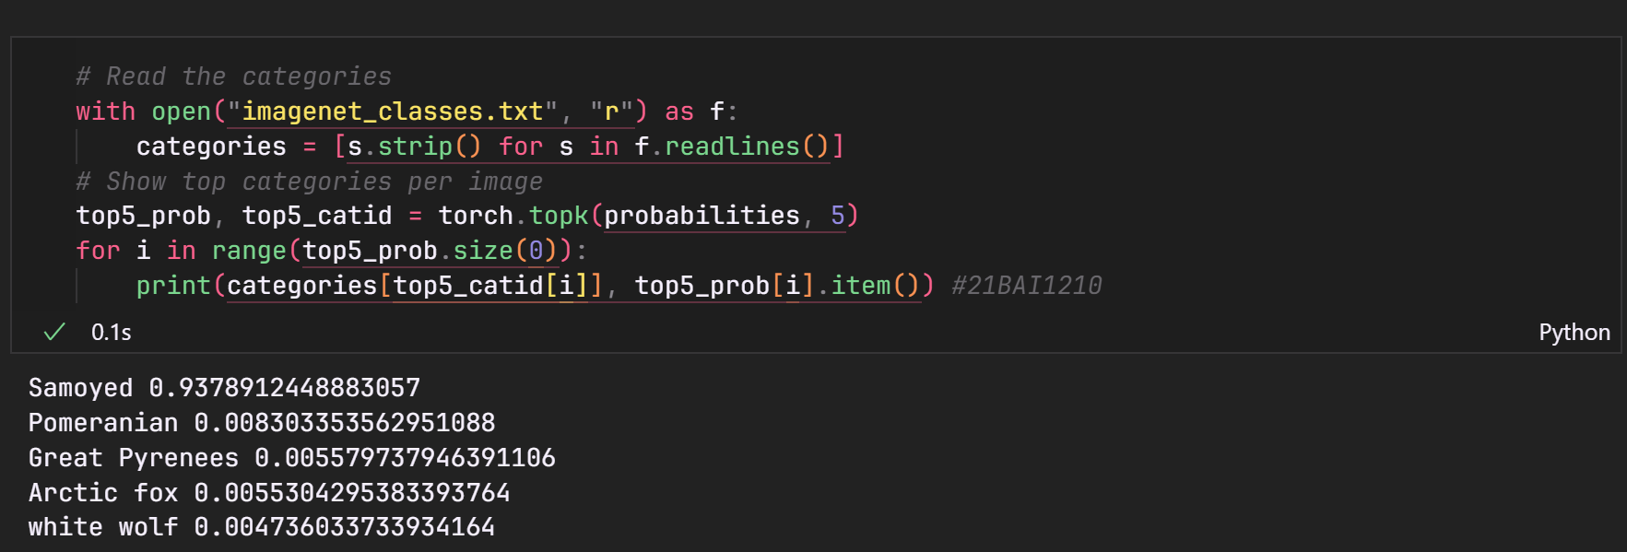

1. PyTorch and GPU

1. VGG16 on CIFAR

1. ResNet on CIFAR

1. GoogleNet vs VGG16

